Mid-Semester Examination
Evaluation Scheme on COA(CS-3005)
- Short Questions [ 1 × 5 ]
  - A computer has 64-bit instructions and 12 bit addresses. If there are 352 three-address instructions, and 2256 no of two-address instructions then how many one-address instructions can be formulated?
Maximum Possible 3 address instructions are:2^{28.}
Maximum possible 2 address instructions are: (2²⁸ – 352) X 2¹²
So, Maximum possible 1 address instructions are: ((2²⁸ – 352) X 2¹²-2256) X 2¹²
  - PC does the same function as MAR, and then justify your answer by keeping two registers instead of one.
PC always holds the address of the instruction which is being currently executed. During the fetch phase of the instruction, the content of PC is incremented, which points to the next instruction of the program. If there is only PC in the processor, then during the execution phase of the instruction, for fetching the operand the same PC can be used and the content of PC which holds the address of next instruction, is lost. Similarly if only MAR is available in the processor, then same problem occurs. Hence at any cost, two registers must be in the processor to help the execution of the program.

  - The content of register R1is 11010110. What will be the decimal value after execution of #2, R1. [ Assume the number is represented in 2's complement format ]

R1 = 11010110 (two times ASR) Result will be R1 = 11110101 (in 2's complement format)
To know the decimal value R1 = 1 1 1 1 0 1 0 1
1 0 0 0 1 0 1 0 in 1's complement format
+ 1
1 0 0 0 1 0 1 1 (result is decimal -11 )
  - Explain the significant of carry and overflow flag.

In computer processors, the overflow flag (sometimes called V flag) is usually a single bit in a
system status register used to indicate when an arithmetic overflow has occurred in an operation,
indicating that the signed two's-complement result would not fit in the number of bits used for the
operation (the ALU width).

In computer processors the carry flag (usually indicated as the C flag) is a single bit in a system
status (flag) register used to indicate when an arithmetic carry or borrow has been generated out of
the most significant ALU bit position.

  - A computer uses a memory unit with 256K words of 32 bits each. A binary instruction code is stored in one word of memory. The instruction has four parts: an indirect bit, an operation code, a register code part to specify one of 64 registers, and an address part. How many bits are there in the operation code, the register code part, and the address part?
Mode | Op-code | Register | Address

256 K = 2⁸ × 2¹⁰ = 2¹⁸
Address = 18 bits
Mode = 1 bits
Register = 6 bits
Total=25 bits
op code =32-25=7 bits

2.

  - How the processor does execute an instruction? Explain with suitable example and neat diagram. [ 2.5 × 2]
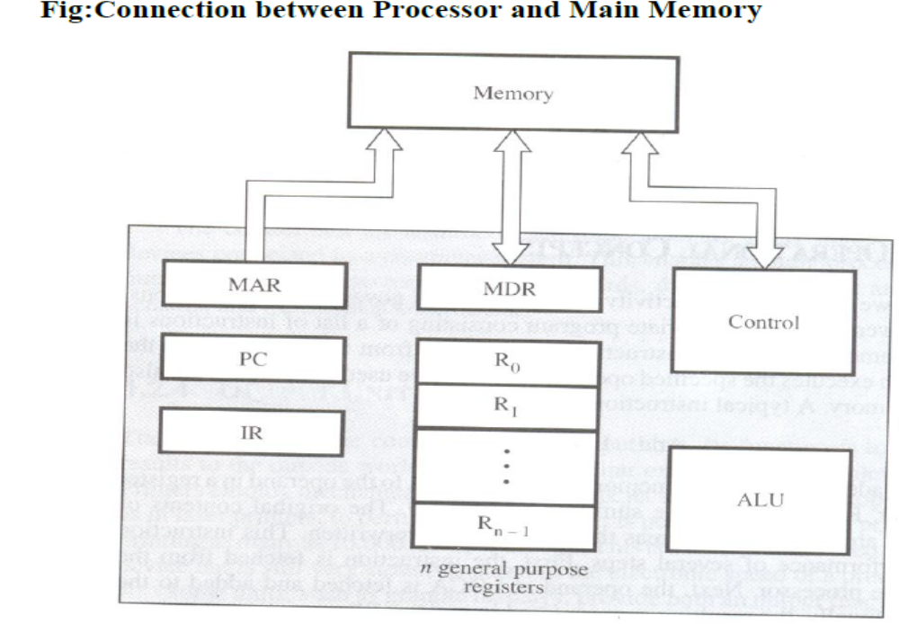

1. Execution starts by loading the address of the instruction into Program Counter (PC).
2. The contents of PC is transferred to the MAR and a READ control signal is issued to the memory.
Then the addressed instruction is read out and loaded into MDR.
3. Next, the contents of the MDR is transferred to the IR & the instruction is ready to be decoded and
executed.
4. The IR is connected to the decoder unit decodes the instruction and activates the appropriate
signals as to what operation is to be performed.
If the instruction involves an operation to be performed by the ALU, then the operand(s) is
required. If the operand resides in memory then it has to be fetched through the MDR by sending
its address to MAR. After all the operands are fetched in this way the ALU can perform the desired
operation.
If the result is to be stored in the m/m, then
a. The address of the location where to be stored is sent to the MAR.
b.The result is sent to the MDR.
c. The WRITE signal is issued to the memory.
d.After some time, the result is written back to the memory.
5. While an instruction is being executed, the content of the PC is updated to point to the next
instruction in sequence. Thus, as soon as the execution of the current instruction is completed a
new instruction fetch can be initiated.
[Diagram:1 mark+Explaination: 1 ½ marks]
b) Explain the following instructions with example.
AND, AShiftR, Compare, Negate, and Branch.

AND: This instruction bit by bit ANDs the src operand to the destination operand. And the result is stored in the destination operand.
Syntax: AND src, dst
Eg. AND NUM, R1
AShiftR:It performs right shift on the operand that may be a register or a memory location by the specified count in the instruction.It inserts the most significant bit of the operand in the newly inserted positions.The result is stored in the destination operand.This shift operation shifts the operand through the carry flag.
Syntax: AShiftR count, dst
Eg. AShiftR #1, R1
Compare: It compares the source operand , with a destination operand by subtracting the source operand from the destination operand but does not store the result anywhere. The flags are affected depending upon the result of the subtraction.
Syntax: CMP src, dst
Eg. CMP #10, R1
Negate: The Negate instruction complements(inverts)the contents of an operand bit by bit.
Syntax: Negate operand
Eg. Neagte R1
Branch: When this instruction is executed , control is transferred to the address specified in the instruction, provided the condition specified is satisfied. If not, execution continues sequentially.
Syntax: Branch condition Label
Eg. Branch>0 L1
[ ½ mark each]

- a) Write the sequence of control steps required for single bus CPU organization of the following instruction
ADD R1, NUM
1. PC _{out,} MAR _{in,} Read, Select 4,Add,, Z _{in}
2. Z _{out,} PC _{in ,} Y _{in} ,WMFC
3. MDR_{out} , IR _{in}
4. Offset_field_of_IR _{out,} MAR _{in,} Read
5. R1 _{out,} Y _{in} , WMFC
6. MDR _{out,} Select Y,Add,Z _{in}
7. Z _{out,} MDR _{in ,} Write
8.WMFC,End.
b) Write the sequence of control steps required for three bus CPU organizations for the above instruction.
1. PC _{out,} MAR _{in,} R=B,Read, IncermentPC_{n}
2.,WMFC
3. MDR_{out} ,R=B, IR _{in}
4. Offset_field_of_IR _{ouA,} R=A,MAR _{in,} Read
5.WMFC
6. R1 _{ouA,} MDR_{outB,} Select A,ADD,MDR _{in,} Write
7.WMFC,End.
c) Design the logic function for WMFC control signal using single bus CPU organization.
[ 2+2+1]
WMFC=T1+T4.ADD+T7.ADD
4) [ 2.5 × 2 ]
a) A two-word instruction is stored in memory at an address designated by the symbol P. The
address field of the instruction (stored at P+1) is designated by the symbol Q. The operand
used during the execution of the instruction is stored at an address symbolized by EA. An
index register contains the value X. State how EA is calculated from the other addresses if the
addressing mode of the instruction is direct, indirect, relative, and indexed.
A two-word instruction is stored in memory at an address designated by the symbol P. The address
field of the instruction (stored at P+1) is designated by the symbol Q. The operand used during the execution of the instruction is stored at an address symbolized by EA. An index register contains the value X. State how EA is calculated from the other addresses if the addressing mode of the instruction is direct, indirect, relative, and indexed.

Mode Opcode
Q
Next instruction

Operand
P
IR = X
P+1
P +2

EA

- Direct :- EA = Q

- Indirect :- EA = Mem [Q]

- Relative :- EA = Q + (P+2)

- Index :- EA =Q + X

b) Write the number of memory references required for executing the following instructions:
    - ADD R1,(R2)+
    - SUB #10,R2
    - MOV R1, 20(R3,R4)
    - AND R1,R2
    - Increment A

i) ADD R1,(R2)+ 3 memory references
( 1 for instruction + 1 for R2 + 1 for store result after Incrementing R2 value)
ii) SUB #10,R2 1 memory references (1 for instruction)
iii) MOV R1, 20(R3,R4) 2 memory references
(1 for instruction +1 for move value to memory Address [20 + R3 + R4] )
iv) AND R1,R2 1 memory references (1 for instruction)
v) Increment A 3 memory references (1 for instruction + 1 for accessing A +1 for
writing the new value into A)
- [ 2+3]
  - Explain the working principle of hardwired control unit design with neat diagram. Explain its advantage and disadvantage.
Hardwird Control
The control units use fixed logic circuits to interpret instructions and generate control signals from them. The fixed logic circuit block includes combinational circuit that generates the required control outputs for decoding and encoding functions.
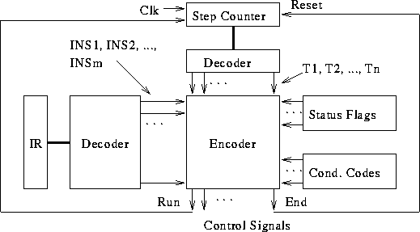

advantage and disadvantage
    - It uses flags,decoder,logic gates and other digital circuits.
    - As name implies it is a hardware control unit.
    - On the basis of input Signal output is generated.
    - Difficult to design,test and implement.
    - Inflexible to modify.
    - Faster mode of operation.
    - Expensive and high error.

[Diagram:1 mark+Explaination: 1 ½ marks]

  - The content of the top of the memory stack is 5000. The content of the stack pointer SP is 3000.
Assume you want to organize a nested subroutine calls on a computer as follows: the routine Main calls a subroutine SUB1 by executing a two-word call subroutine instruction located in memory at address 1000 followed by the address field of 6000 at location 1001.Again subroutine SUB1 calls another subroutine SUB2 by executing a two-word call subroutine instruction located in memory at address 6050 followed by the address field of 8000 at location 6051 . What are the content of PC, SP, and the top of the stack?
      - After the subroutine call instruction is executed in the main routine?
      - After the subroutine call instruction is executed in the subroutine SUB1?
      - After the return from SUB2 subroutine?
i.
PC : 6000
SP : 2998
stack[Top]:1002
ii.
PC : 8000
SP : 2996
stack[Top]:6052
iii.

PC : 6052
SP : 2998
stack[Top]:1002

- [ 2+ 2+1]
Write a program to evaluate the arithmetic statement:
X = (A-B+C*(D*E-F)) / (G+H*K)
    - Using a stack organized computer with zero-address operation instructions.
    - Using an accumulator type computer with one address instructions.
Using a general register computer with two address instructions

Ans:
- Zero-address Instructions

PUSH D
PUSH E
MUL
PUSH F
SUB
PUSH C
MUL
PUSH A
PUSH B
SUB
ADD
PUSH H
PUSH K
MUL
PUSH G
ADD
DIV
POP X

- One-address Instructions

LOAD D
MUL E
SUB F
MUL C
STORE T
LOAD A
SUB B
ADD T
STORE P
LOAD H
MUL K
ADD G
DIV P
STORE X

- Two-address Instructions

MOV D, R1
MUL E, R1
SUB F, R1
MUL C, R1
MOV A, R2
SUB B, R2
ADD R2, R1
MOV H, R3
MUL K, R3
ADD G, R3
DIV R1, R3
MOV R3, X

